MagLoc:Indoor Localization using Geomagnetic, WiFi, and INS

Kaiyao Wang¹, Yongjun Liu¹, Zhihao Xing¹, Weipeng Jiang¹, Hui Yang¹, Yun Lei¹, Xun Yang¹
Haiyong Luo², Dongmeng Li², Qu Wang²
Wenhua Shao³, Fang Zhao³
¹Huawei Technologies Co.,Ltd. Beijing, P.R. China
²Institute of Computing Technology, Chinese Academy of Sciences. Beijing, P.R. China
³School of Software Engineering, Beijing University of Posts and Telecommunications. Beijing, P.R. China
{wangkaiyao, liu.yongjun, xingzhihao, jiangweipeng, yanghui.yang, leiyun, yangxun.yang}@huawei.com, {yhluo, shaowenhua}@ict.ac.cn

ABSTRACT
Most of indoor localization solutions currently rely on uncommonly technologies such as ultra wide band (UWB), LED lights, ultrasonic. However, in these solutions the hardware modification was required. In this work, we developed a low-cost indoor localization system which relies on WiFi signals and smartphone sensors. Specifically, a practical and accurate smartphone localization solution is presented, and it has some excellent characteristics: high accuracy; no requirement of additional hardware components on the receiver side; using the existing infrastructure.
Keywords
Indoor localization, Geomagnetic, CSI, Particle filter, Inertial navigation

1. INTRODUCTION
Satellite based localization systems (such as GPS, GLONASS, BeiDou) cannot be used indoor and in underground environments. Hence, a lot of attention is focused on indoor localization in recent years. As a result a number of technologies and solutions were developed, such as ultra wide band (UWB), LED lights, ultrasound, to name a few. However, these solutions require deploying special infrastructure, which impedes immediate viability.
In this work, we propose a real-time localization system for both static and mobile scenarios with commodity off-the-shelf (COTS) smartphones. The proposed system is named as MagLoc which can be used to localize smartphones with no-additional hardware.

2. SYSTEM DESIGN
The MagLoc indoor localization system combines geomagnetic matching, INS, altitude measurement, WiFi fingerprint and particle filer together, as shown in Fig.1.
Figure 1: Localization system diagram
Our system is divided into two phases: the training phase and the online localization phase.
2.1 Training Phase
The training phase is used to construct two kinds of fingerprint maps. Measurements of the geomagnetic field and received signal strength indicator (RSSI) or channel state information (CSI, which is fine-grained information and may enhance accuracy of location significantly) are collected to respectively generate the geomagnetic fingerprint and the WiFi (RSSI/CSI) fingerprint using the map information. The WiFi fingerprint is exploited to estimate target initial or coarse location. Three elements will be recorded in the geomagnetic fingerprint map: magnetism magnitude, orientation offset and map information.
In the indoor environment, magnetic signal is various. Although 3 axis changes when the smartphone is on different posture and placement, the combination of them remains stable. So we choose $mg=\sqrt{m_{x}^{2}+m_{y}^{2}+m_{z}^{2}}$ as the magnetic feature of fingerprinting from raw data.
2.2 Localization Phase
In the localization phase, the fingerprints are exploited to estimate the position of smartphones together with measurements of sensors.
- Geomagnetic matching
The geomagnetic fingerprints matching is a time series matching problem, which can be utilized to obtain accurate location estimate. As the sampling rate might be different and the speed of device movement might be different as well, time series may be “warped” non-linearly by stretching or shrinking it along its time axis. Based on the fact that Dynamic Time Warping (DTW) algorithm can find the optimal alignment between two time series, the DTW is used to evaluate the geomagnetic time series similarity to update the weight of particles for each step and calibrate the target position with geomagnetic trajectory matching result in our system.
- Particle filter
Particle filter algorithm integrates information from the INS module, barometer, WiFi matcher and geomagnetic matcher, to estimate the posterior distribution of the target position. The state of each particle consists of two pixel coordinates x and y on the map, accuracy estimated, a direction d, a step length l, history state of each step, and history of magnetic data. Those altogether contribute to the final result.
On the initialization stage, particles are distributed according to the result with WiFi matcher. After that, once a step is detected, the states of particles are updated with the newly collected data. On the prediction stage, all particles move according to the move model. And weights update relies on the observation model, which will make full use of collected signal data. Then follows a resampling step, where particles with higher weight are split and those who bump the wall are killed. Finally the update phase is proceeded normalizing the weight of all particles according to the measurement model, and the final position estimation result is packed and delivered.
MagLoc system consists of existing Wi-Fi devices and a tag node. Figure 2 shows the system deployment.
Figure 2: Example deployment of our system.
The tag node can be a common portable device, such as laptop, smartphone. MagLoc system runs locally on a smartphone, shown in Fig.3. The proposed system is a low-cost scheme without requiring any additional hardware.
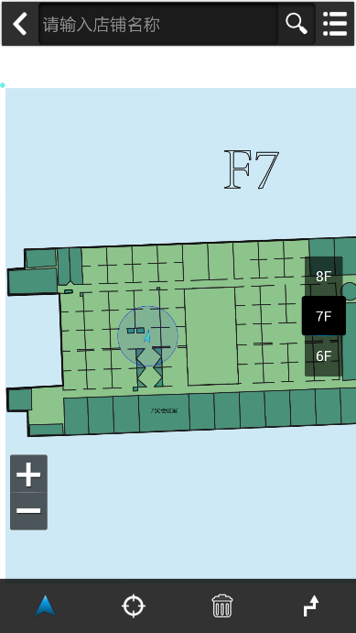
Figure 3: MagLoc system interface

3. REFERENCES

- Rui Tao, Haiyong Luo, Fang Zhao, Yongzhong Li. Multimodal Algorithm Based on Particle Filter for Indoor Localization with Smartphones. International Conference on Computer, Communications and Information Technology (CCIT),2014.

