Precise Hand-held Indoor Location

Lingxiang Zheng, Ao Peng
Zongheng Wu, Yizhen Wang, Xiaoyang Ruan, Zhenyang Wu, Hao Li
School of Information Science and Engineering,
Xiamen University,
Xiamen, China
Email: lxzheng@xmu.edu.cn

Abstract—We present a smart phone-based indoor positioning system. The system uses build-in accelerometer and gyroscope of a smart phone. Raw measurements of accelerometer and gravity sensors are used to calculate pedestrian trajectory. Gyro output is used to estimate the direction angle of each sampling point. A Kalman filter is used to eliminate vertical speed offset due to the accelerometer drift errors, reducing estimation error of the step length of each step. Based on the pre-mapped indoor map, a particle filter based on map matching algorithm is proposed to eliminate the heading and step length error. While in scenes with rich feature points, Project Tango can be used to limit the system error in addition. The major advantages of our system are: low cost, no need of external infrastructures, no need of calibrations of fingerprinting measurement campaigns.
Keywords—smartphone; Kalman filter; Particle filter; indoor positioning

Introduction
In many applications, indoor positioning is required, in particular where the Global Positioning System (GPS) is not available, for example, tracking a firefighter in fire scenes, looking for a car in an underground parking, tracking health-care workers and instruments in a hospital, and so on.
Currently, most indoor positioning methods use infrastructure-based approaches and rely on the signals of external devices. It limits their usability, especially when there are not any external sources of signals or these signals are hard to setup. Moreover, the wireless signal source is vulnerable to interruptions or interferences, which makes it harder to establish an accurate and stabilized indoor positioning system.
Infrastructure-free-based approaches eliminate the needs of external signals. Most of these approaches are based on inertial sensors, i.e., accelerometers and gyroscopes. These sensors can accurately collect data in a harsh environment. However, the drift and bias errors of these sensors cause serious problems.

System design
The overall design and the execution framework of the system is shown in Fig.1. The system consists of six modules: data acquisition, ZUPT, step length calculation, Kalman filter, map matching and trajectory calculation.
We developed an indoor positioning system using a smartphone held on hand static to body. This method uses a smartphone application to collect the data of phone's built-in accelerometer, gyroscope and virtual gravity sensor.
The drift and bias errors of the sensors cause serious problems. Such errors can accumulate over time, so the measured acceleration over time accumulated an increasingly large error. We use a zero velocity update method (ZUPT) method to overcome the sensors errors and improve the accuracy significantly. The outputs of the accelerometers and gravity sensor are sent to ZUPT module to detect the zero vertical velocity moments.
A 5-dimensional Kalman filter is designed accordance with the motion equation to fusion the outputs of the sensors and to estimate the non-linear error of the vertical velocity and heading that increases over time. The vertical displacement is the integral of vertical velocity, step lengths are then obtained using the Pythagorean Theorem given the length of legs. The heading of each step can be estimated by the angular velocity measured by gyroscope.
In addition, while floor plan is available, a Particle filter based map matching algorithm is used to eliminate the heading and step length error.
In scenes with rich feature points, we can also fuse the output of Project Tango to limit system error.
Fig. 1. System architecture

DEMONSTRATION APPLICATION
With the object to examine indoor positioning performance, an Android mobile application was created. Before positioning, if available a special file of floor plan should be preloaded into smartphone for using during positioning.
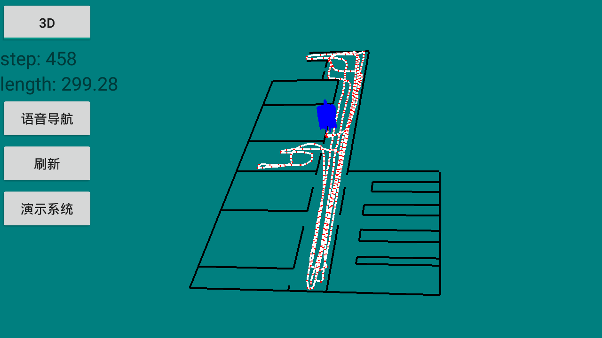
Fig. 2. The screenshot shows the user’s position and the trajectory.
User should determine the initial position and initial heading through gestures on screen. Then user’s trajectory and position will be shown on a floor plan while walking as Fig.2.

Requirements
This system requires no external infrastructure, phone will be held on hand, initial position and heading should be determined by user.

