The design of backlights for view-sequential 3D
Adrian Travis, Neil Emerton, Tim Large, Stephen Bathiche
Microsoft Corporation, One Microsoft Way, Redmond, WA 98052, USA
Abstract
We have demonstrated a backlight which emits collimated light whose direction can be scanned through 16°. Combined with a high frame rate LCD, this lets us display stereo 3D with no need for glasses.
- Introduction
A conceptually simple way to display a three dimensional image is to illuminate a liquid crystal panel with collimated light whose direction can be scanned. Display a sequence of views of the three dimensional image on the liquid crystal display while illuminating each with light travelling in the direction from which the view was captured and the result is a three dimensional image which is free of flicker if it is repeated sufficiently quickly.

While ferroelectric liquid crystals and poly-silicon transistors have long had the switching times needed to enable this, the display industry has instead developed nematic liquid crystals and amorphous silicon transistors which switch too slowly for view-sequential 3D. However, work on stereo-3D and colour sequential displays has caused the frame rate of liquid crystal displays to rise, while advances in head-tracking technology have led to a reduction in the number of views needed and therefore to a reduction in the frame rate required of the liquid crystal display. This approach therefore deserves fresh examination but there is needed a slim backlight which emits collimated light whose direction of collimation can be scanned.

An interesting concept using electro-wetting is perhaps too slow for this application and the authors confined themselves to approaches using passive waveguides.
Virtual image displays inherently have the ability to emit light in the manner needed for view-sequential 3D and a virtual image can be ejected from a flat panel waveguide if it is embossed with a weak diffraction grating. Such a device can indeed be used to display a three dimensional image but light must be collimated before it is injected into the slab waveguide which requires a second collimating waveguide that makes the display bulky.

A wedge waveguide can also be configured to emit collimated light and it was recently explained how ray fan-out can take place in the same wedge as that from which collimated light emerges. Here we examine how the direction of emitted light alters with the point of input and what aberrations occur.
- Theory
Rays leave a light-guide only upon reaching the critical angle so we can trace rays in parallel at this angle backwards from the surface at which they are to emerge. From within, any light-guide appears like a kaleidoscope as if the rays were travelling in straight lines through multiple reflections of the guide as shown in cross-section in figure 1.
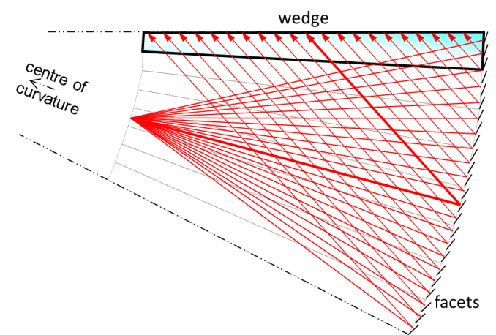
Figure 1: The thick end is curved and faceted so as to concentrate ray paths to a point at the input
We arrange that the rays reflect off the thick end before they emerge and we curve the thick end so that the multiple reflections of figure 1 stack into a curve of constant radius. When parallel rays reflect off a curve, they concentrate at a distance halfway to the centre of curvature and we truncate the wedge at this point.
Our backward-traced rays must not reach the critical angle before reaching the thin end so we emboss the thick end with facets sloped to reduce ray angle. These facets will ideally swivel the point of focus to a position where the central ray is reflected parallel to the plane of the wedge because the ray bundle will then be symmetric which maximizes étendu. However, reflections of the facets are formed at the interface between adjacent wedges so our embossed structure must be symmetric i.e. a zig-zag, which means that half of all backward-travelling rays are lost to the system.
In reality, our rays are travelling forward from thin end to thick and because the situation they encounter is symmetric, no rays are lost: rays hitting upward sloping facets emerge from the upper surface of figure 1 while rays hitting downward sloping facets emerge from the lower surface. It is then a simple matter to add a mirror to one surface of the wedge so that all finally emerge from the same side.
The direction of rays resolved in the plane of the light-guide must also be made parallel which we do by giving the thick end of the light guide the same curvature as in figure 1, i.e. its surface, facets aside, is spherical. Furthermore, we add prismatic film so that the rays which emerge into the surround at a shallow angle to the plane of the light-guide are turned to the perpendicular.
- Results
Our Wedge backlight is an acrylic slab which tapers from a thickness of 6.2 mm to 10.8 mm over a distance of 320 mm and it is 195 mm wide. At ± 30 mm about the centre of the thin end were placed from right to left three red, three green and three blue light emitting diodes.
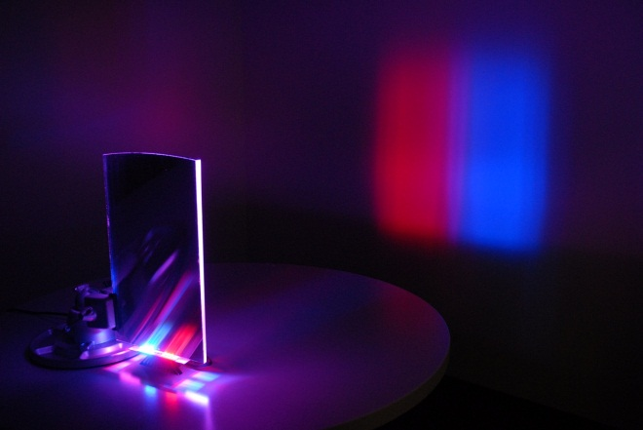
Figure 2: Projection onto screen 2 metres from a wedge backlight with 30 mm separation between red and blue sources at input
Initially only the red and the light emitting diodes were switched on and there formed on a white surface placed 2 metres in front of the backlight the image of figure 2.
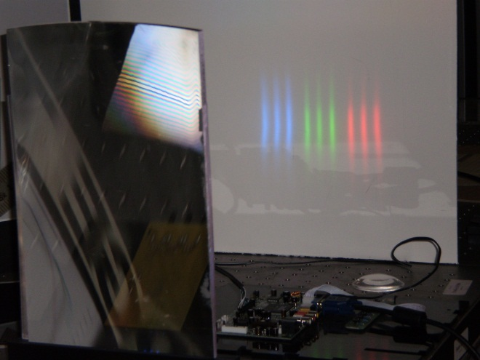
Figure 3: Projection from a wedge backlight via a 450mm focal length Fresnel lens onto a 570 mm distant screen
Next, a Fresnel lens with a focal length of 450 mm was placed over the surface of the light guide whereupon there formed the image of figure 3 at a distance of 570 mm from the backlight. The width of the projected image was 160 mm, the result of which would be a 3D image with a field of view of 16°.
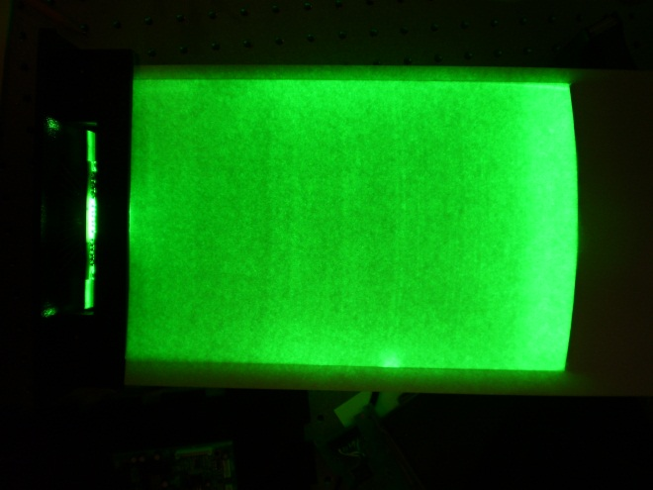
Figure 4: Wedge backlight with 3 green LED’s within 30 mm width at input and with white paper diffuser over surface
Lastly, the central green LED’s were switched on alone and white diffusive paper was placed over the surface of the wedge in order to show uniformity. A photograph of the result is shown in figure 4 and more rigorous measurements at various points across the surface indicated a non-uniformity of less than ±10%. In order to assess performance when illumination is off-perpendicular , the red LED’s were switched on instead but there were no perceptible shadowing or vignetting.

- Discussion
To the extent that it collimates light, the light-guide can be thought of as a flattened lens with a quasi one-dimensional focal plane at the thin end. Apart from the astigmatism introduced by the turning film, the aberrations are those of a spherical mirror and this is what will limit performance both at large angles to the perpendicular and when the display is much wider than it is high. However, for applications such as in portable devices where the display is held like a portrait and where there is only one user, the backlight is a way not only of providing 3D images but also of reducing power consumption by not wasting light to wide angles.

- Conclusions
We have demonstrated a slim backlight with the ability to produce collimated light whose direction of collimation can be scanned. Uniformity is good and when combined with a high frame-rate liquid crystal display, we expect to be able to produce 3D images with a 16° field of view in azimuth.

- References

A. Travis,” Autostereoscopic 3-D Display”, Applied Optics, Vol. 29, No. 29, pp.4341-2, 1990
S. S. Kim, B. H. You, H. Choi, B. H. Berkeley, D. G. Kim and N. D. Kim, “World’s First 240Hz TFT-LCD Technology for Full-HD LCD-TV and Its Application to 3D Display”, SID Symposium Digest of Technical Papers June 2009 Vol. 40 pp. 424-7
A. Schwerdtner, N. Leister, R. Häussler, S. Reichelt, G. Fütterer and A. Schwerdtner, “Eye-Tracking Solutions for Real-Time Holographic 3-D Display”, SID Symposium Digest of Technical Papers May 2008 Vol. 39, pp. 345-7
C. Lee and A. Travis, “Flat-panel backlight for view-sequential 3D display”, IEE Proc.-Optoelectronics, Vol. 151, No. 6, December 2004
A. Travis, T. Large, N. Emerton and S. Bathiche, “Collimated light from a waveguide for a display backlight”, Optics Express, Vol. 17, Issue 22, pp. 19714-19719

